**Technical Advisory Group Meeting Summary**

May 14, 2024, 9:00 - 2:30

Kitsap County Admin Building – Commissioner’s Chambers

619 Division Street, Port Orchard, WA  98366

**Decisions by TAG**

|  |
| --- |
| Approved May consent agenda and April meeting summary |
| Approved Providing Letter of support to Mid-Sound to advance design work for the Point No Point Estuary Restoration (NFWF). |
| Approved Providing letter of support for South Sound Shore Friendly (ESRP) Mason, Thurston, and Pierce. |
| Approved Providing letter of support for Schoolhouse Creek (PSAR Large Cap). |
| Approved Providing letter of support for Shore Friendly Kitsap. |

**Action Items Status**

|  |  |
| --- | --- |
| Renee - find out which grants require the new tribal notification requirements and send out to the TAG. | Complete |
| Renee – Where will the new Lead Entity be? | Complete  Spokane Salmon Restoration Collaborative as the Spokane River watershed lead entity.  The lead entity territory lies in Water Resource Inventory Areas 54, 55, 56, and 57, in Lincoln, Pend Oreille, Spokane, Stevens, and Whitman Counties.  The focus of the lead entity will be preparing for the reintroduction of non-Endangered Species Act-listed spring and summer/fall Chinook salmon in the Spokane River watershed and improving habitat conditions for native redband trout, which are linked ancestrally to extant steelhead trout populations and are listed as a species of concern by the U.S. Fish and Wildlife Service. |

**Welcome, Introductions and Business Items:**

Co-Chair, Erik Steffens opened the meeting, welcomed all who were there, started round table introductions.

Erik Steffens opened the meeting for public comment. No members of the public were present.

Zach Holt shared an article about beavers from Wildlife Professional magazine.

*Decision: Approve May consent agenda and April meeting summary* (Motion – Steve Todd, Second – Zach Holt, no objections, no abstentions)

**Standing and emerging topics**

**Large Cap Update**: Renee Johnson shared the 2024 WSPER preliminary large cap projects list (p. 17 of the meeting packet). On this list of projects, Pierce County’s School House Creek at Tidewater has been invited to submit and application.

**Salmon Recovery Council Report out:**

Brittany Gordon gave a brief update on the Salmon Recovery Council meetings. The Puget Sound Salmon Recovery addendum is still in review and revision and includes specific actions for lead entities. Brittany is also serving on the SRC's Accelerating Progress committee, which is recommending strategies to break down barriers in permitting, railroads, and transportation. Brittany has specifically had a lot of ideas on the transportation side, such as incorporating salmon recovery goals into corridor studies and NEPA. The Gorst Corridor Study is upcoming and may be a good opportunity to look for collaboration.

**New tribal notification requirement:** Certain grants have a tribal notification requirement such as PSAR Large Cap and ESRP. Some of you may be submitting these already. The grants requiring these are the grants that are funded with the new Climate Commitment Act.

*Action Item - Renee Johnson find out which grants require the new tribal notification requirements and send out to the TAG.*

**Updates to PPFL due June 1, updates to 4-Year Workplan due mid-July**

PPFL needs to be a tight assessment of what we think people will be applying for. 4YWP needs to be tightened up. This also helps us with our longer-term projects as well. We will be setting up a meeting with everyone to learn more about each project. Even for those who have responded. Meetings will be set up 15 minutes to an hour depending how many projects you have.

Discussed PROTECT funding. Discussed strategies for work plans and other funding, with a reminder that it was very important to keep the PPFL and 4YWP up to date, dialing in with each project sponsor.

Discussed RAFT and HSIL Capacity grants.

**Discussion and Decision Items**

*Discussion items:* *Crabapple/Carpenter & Salmonberry Protection*

*What to do with $37,635.94 of 21-23 PSAR return funds (expiring June 30, 2025).*

We have options we could fund down the list, set aside for cost increases to existing projects, or put it towards the 2024 grant round.  It is old money and to be used before it expires.

Steve asked: How have we dealt with cost increase in the past, or how has that been addressed in the past? Renee shared that it really depends on if the funds are SRFB or PSAR and that there are different rules for each of them. Sometimes we can use our own funds, sometimes we put in a request for a cost increase – PSAR money regionally (return funds). If we don’t use the PSAR money, it goes back to the regional funds and someone else can receive it. If you hang on to the funds for too long you can lose it. We need to be sure the projects that receive these funds are ready to use them.

Christina asked about splitting funding to multiple projects to fit needs where the money would be able to be used right away, such as permitting and designs. Renee shared that that would be up to the grant manager.

Renee reviewed last years decisions for how the TAG funded projects. She shared that some of those projects received additional funds from other sources, therefore they will not need our 2023 allocation. The decision made by the TAG in 2023 was that if any money came back it would flow down the list. Those projects are in out grant round this year and dollar amounts have changed. Would it still be important to keep them in the ranking, just in case.

Mary asked if there were 2023 project sponsors who would want to share thoughts about the 2023 funds.

* Kitsap Conservation District could definitely use the funds but would need it in a later time frame.
* Fawn – Barnabee is ready to go.

The TAG decided that they would rank and vote on the 2024 grant round projects first and then decide on how best to utilize the $37,635.94 of 21-23 PSAR return funds.

**Decision Items**

Provide Letter of support to Mid-Sound to advance design work for the Point No Point Estuary Restoration (NFWF and Paul G. Allen Fund Supporting Natural Climate Solutions)

* Steve opened for questions and comments. Mid-Sound shared they were only requesting a letter of support for NFWF, they were not invited to in the Paul G. All Funds. Renee shared the submitted information from Mid-Sound for the letter of support. Antonia explained how this project went in as a fish project, but it is also a coastal resilience project as restoring the marsh would provide a natural solution.

*Decision Item: Provide Letter of support to Mid-Sound to advance design work for the Point No Point Estuary Restoration (NFWF).*

*(Motion – Marty Ereth, Second – Jaime Glasgow, no objections,* *abstentions Brittany Gordon and Antonia Jindrich)*

Provide letter of support for South Sound Shore Friendly (ESRP) Mason, Thurston and Pierce.

- Steve opened for questions and comments. Mary stated that she is asking for a letter of support for the three conservation districts that Shore Friendly program should continue in the South Sound.

- Christian asked how the funding is used. Mary shared that funding is used in combination of supporting staff, paying for consultant expertise, workshop outreach, beach walks, and technical assistance programs. Mary’s Program has reached over 320 parcels in the last 6 years.

Christian then asked if counties or cities contribute from their budgets for any of the work. Mary informed the group that in Mason, Thurston, and Pierce Counties those programs are hosted in only the Conservation Districts. Although throughout the agency they are hosted through different avenues.

*Decision Item: Provide letter of support for South Sound Shore Friendly (ESRP) Mason, Thurston, and Pierce*.

*(Motion – Christian Berg, second – Zach Holt, no objections,* abstentions - *Mary Krauszer*)

Provide letter of support for Schoolhouse Creek (PSAR Large Cap)

-Steve opened for questions or comments. There were none.

*Decision Item: Provide letter of support for Schoolhouse Creek (PSAR Large Cap)*

*(Motion – Antonia Jindrich, second – Christina Kereki, no objections,* abstentions *- Marty Ereth)*

*Christina Kereki made a request to edit the agenda by adding a decision item to provide a letter of support for Shore Friendly Kitsap.

- Christina Kereki shared that the funding would provide outreach, beach walks, workshops, develop armor removal projects, this time around Shore Friendly Kitsap is partnering with Mid Sound Fisheries.

Enhancement Group. Funds cover staff and homeowner incentives; she will also expand the program to cover design and permitting services to cover a couple projects.

*Decision Item: Provide letter of support for Shore Friendly Kitsap.*

*(Motion – Zach Holt, second – Mary Krauszer, no objections,* abstentions *- Christina Kereki and Antonia Jindrich)*

**Grant Round**

Discuss and rank projects.

* Renee shared the 2024 WSPER TAG Grant round scoring responses with the TAG, went over the packet and materials, and presented Salmon the Washington Way.
* Renee reviewed the grant round funding and key questions to with the TAG to keep in mind when making decisions and ranking.
* The TAG discussed different scenarios for using returned funds.
* The TAG discussed both the standard and normalized scores and both ranked lists.

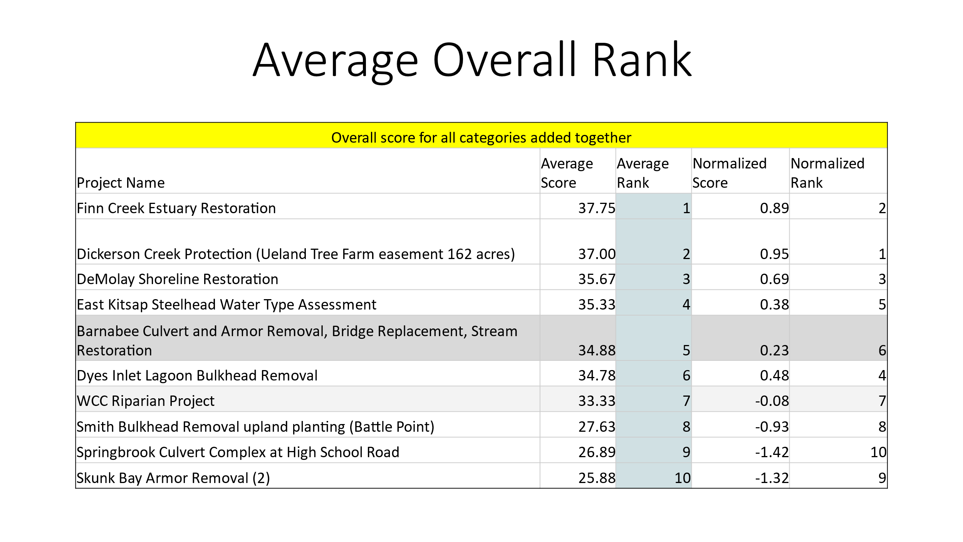

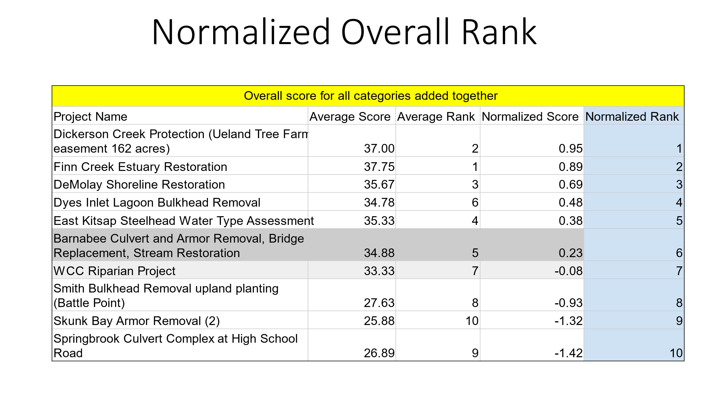

After some discussion about normalized scores, initiated by Jamie Glasgow, Renee presented two different scenarios for consideration. These scenarios would also allocate returned funds with consideration for which sponsor could spend the funds expiring soonest.

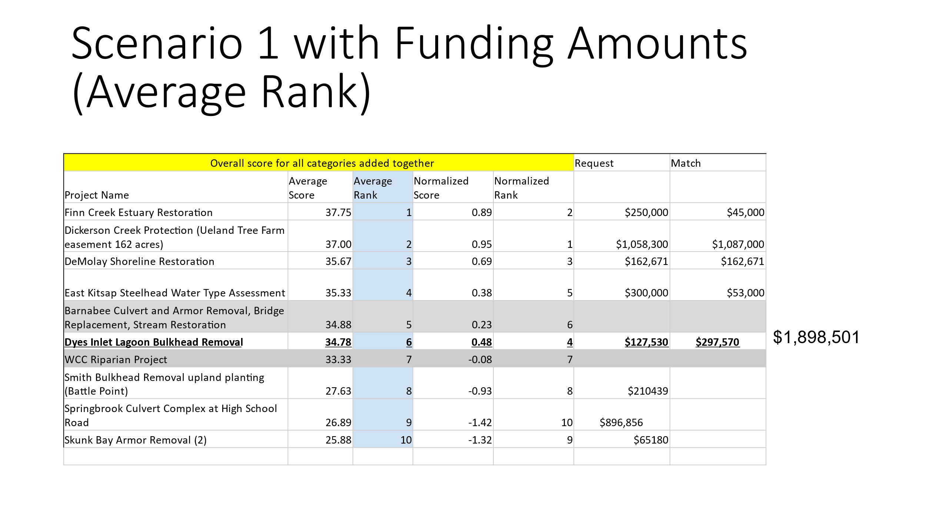

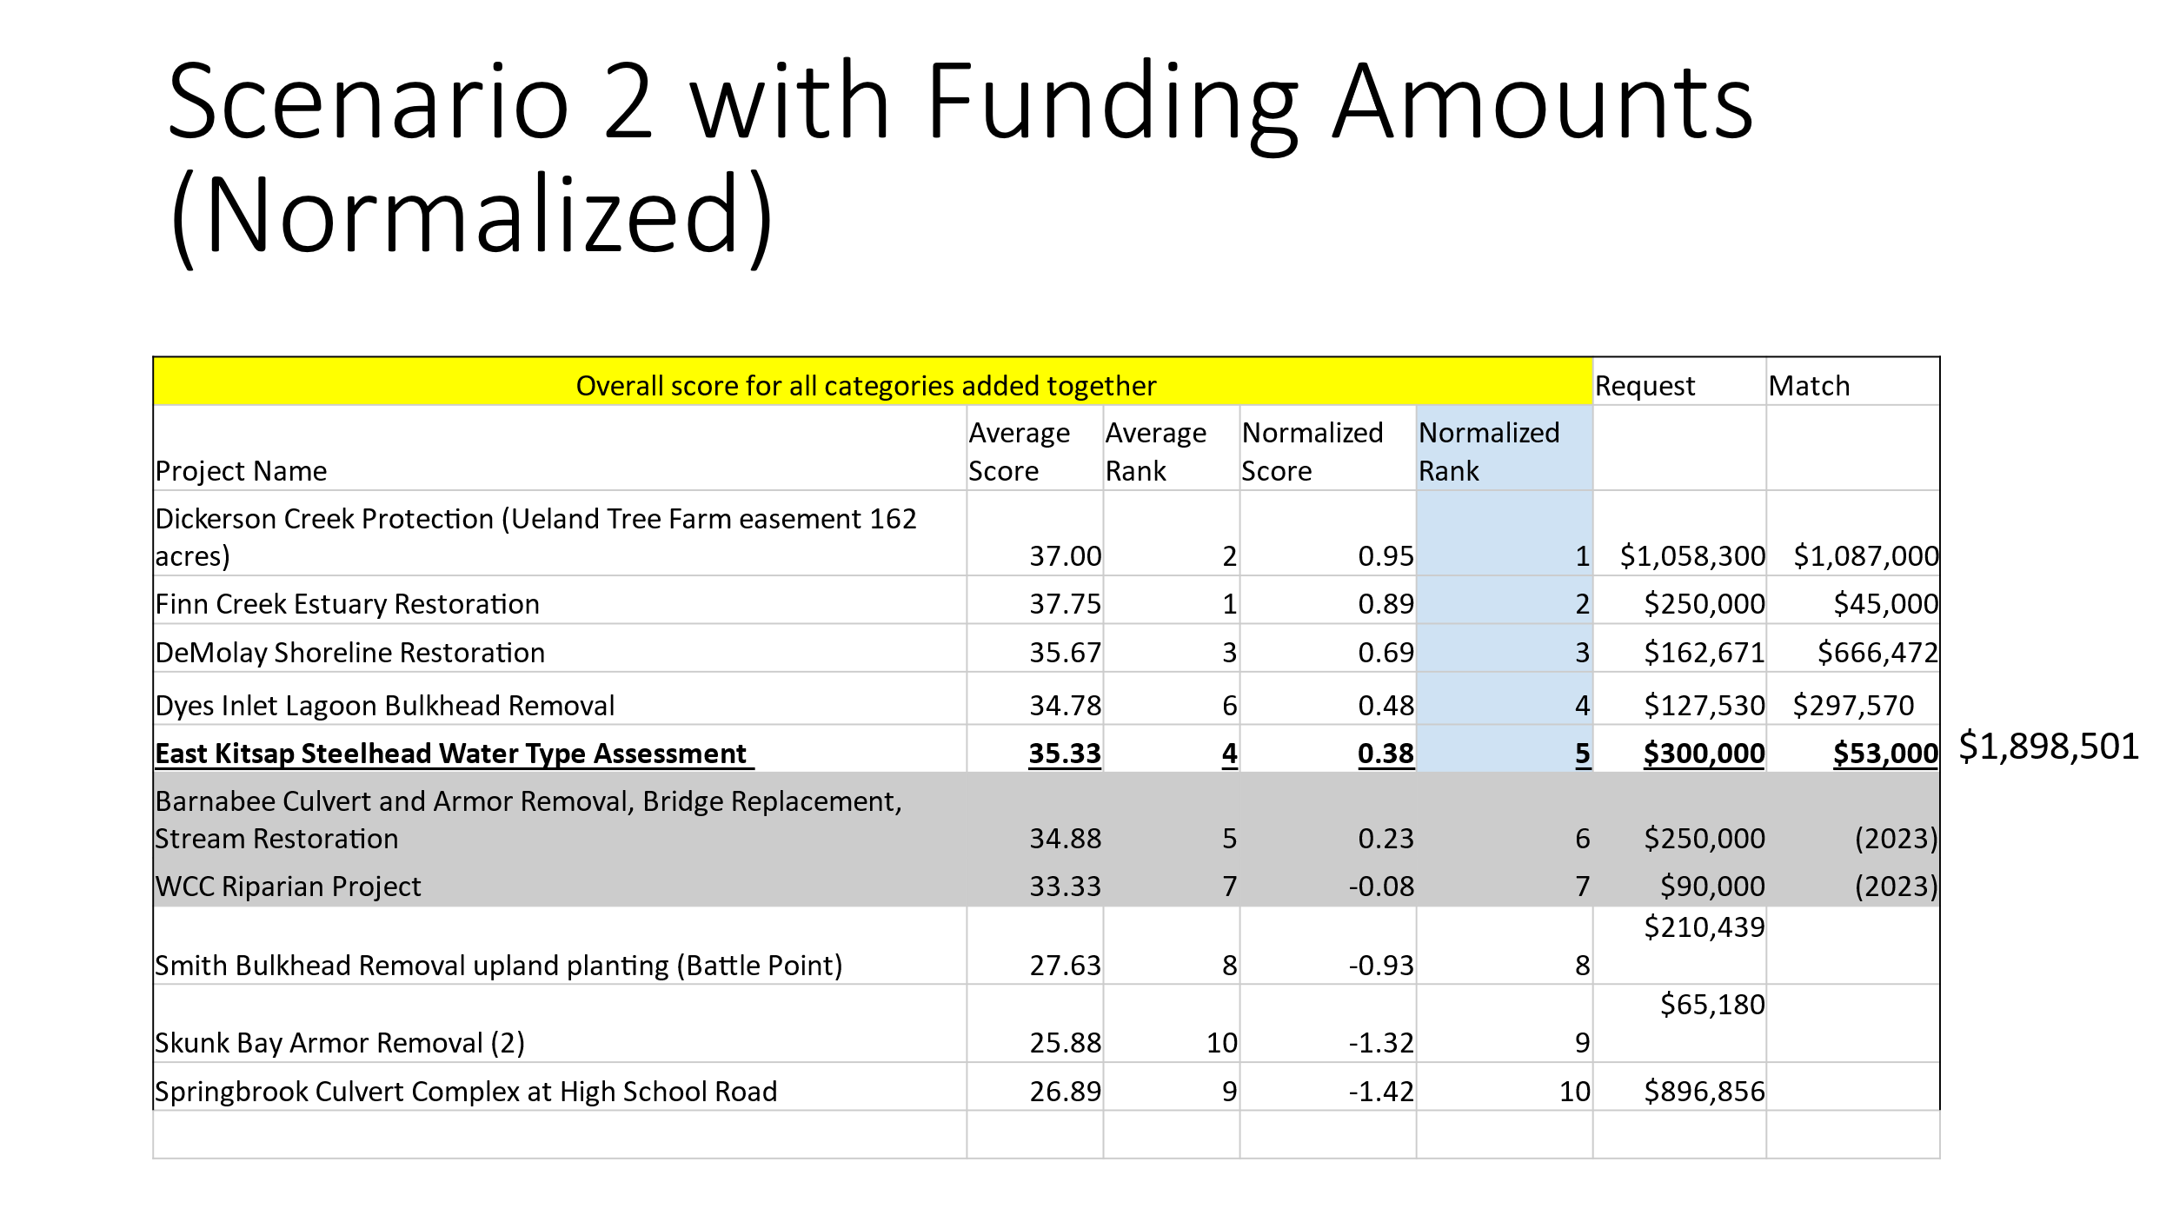

After some deliberation and discussion, there was a motion to support Scenario 2. Motion made by Mary Krauszer, seconded by Marty Ereth. The motion passed unanimously. As new TAG candidates, Fawn Wagner and Rachel Bowen abstained. Renee Johnson and Brittany Gordon, WSPER Coordination Team, also abstained.

The ranked list below was produced from Scenario 2 above.



**Attendees:**

Amy Smalley, Kitsap County / WSPER Team

Antonia Jindrich, Mid Sound Fisheries Enhancement Group

Brittany Gordon, Kitsap County WSPER

Carin Anderson, Kitsap Conservation District

Christian Berg, City OF Bainbridge Island

Christina Kereki, Kitsap County / Shore Friendly Kitsap

Erik Steffens, Great Peninsula Conservancy / Co-Chair

Fawn Wagner, Bainbridge Island Land Trust

Jamie Glasgow, Wild Fish Conservancy

Marty Ereth, Pierce County

Mary Krauszer, Pierce Conservation District

Lisa Reynolds, Mid Sound Fisheries Enhancement Group (Online)

Rachel Bowen, City of Poulsbo

Renee Johnson, Kitsap County / WSPER

Steve Todd, Suquamish Tribe/ Co-Chair

Zach Holt, City of Bremerton