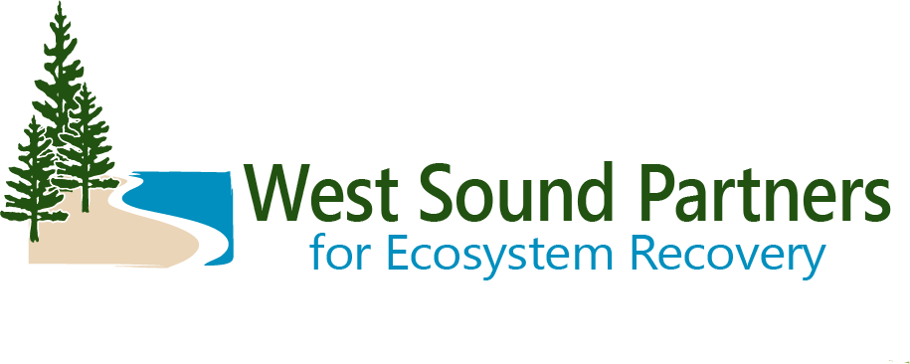

**Executive Committee Meeting**  
December 13, 2023, | 1:00 PM – 3:00 PM

Meeting Summary Draft

|  |  |
| --- | --- |
| **Action Item** | **Responsible Party** |
| Renee Johnson will set up a meeting to further discuss the Mobile Marine Pump Out Project with possible sponsor | Renee Johnson |
| Share Brittany’s Beaver Presentation slides with City of Bainbridge Island | Brittany Gordon |
| **Decisions/Recommendations** | |
| Approved consent agenda (December agenda and June summary) | |
| Approved 2024 Workplan | |
| Nominated andconfirmed the 2024 Executive Committee Officers | |
| Nominated and Confirmed the Salmon Recovery Council Representatives | |
| Decision was made to Postpone the Leadership Council Forum | |
| Approved WSPER’s 2024 Salmon Recovery Grant Round Schedule | |

**Executive Committee Members in Attendance**  
Chairman Forsman, Suquamish Tribe

Charlotte Garrido, Kitsap County, Commissioner

Greg Wheeler, City of Bremerton, Mayor

Robyn Denson, Pierce County, Councilmember

Roger Henderson, City of Gig Harbor, Councilmember

Becky Erickson, City of Poulsbo, Mayor

Joe Deets, City of Bainbridge Island, Councilmember  
Chris Hammer, City of Port Orchard, City Engineer

**Staff and others in attendance**

|  |  |
| --- | --- |
| Amy Smalley, Kitsap County  Barbara Ann Smolko, Pierce County  Brittany Gordon, Kitsap County  Don Gourlie, Puget Sound Partnership  Jenn Grimm, Puget Sound Partnership  Kirvie Mesebeluu-Yobech, Kitsap County | Marty Ereth, Pierce County  Michael Abboud, City of Gig Harbor  Rachel Bowen, City of Poulsbo  Renee Johnson, WSPER Coordinator  Sadie Normoyle, Puget Sound Partnership  Steve Todd, Suquamish Tribe |

**Welcome and Introduction**

Leonard Forsman, WSPER Chair and Suquamish Tribe Chairman, opened the meeting and led introductions.

Renee Johnson, Kitsap County/WSPER Coordinator, reviewed the agenda and meeting purpose.

There were no public comments.

The Executive Committee established a quorum. The group approved the consent agenda via a motion by Roger Henderson, seconded by Joe Deets. There were no objections or discussion.

***Decision:*** Approved consent agenda (December agenda and June summary).

**Decisions and Recommendations**

**Review 2024 Work Plan**

The Executive Committee reviewed the 2024 West Sound Partners for Ecosystem Recovery work plan.

Chairman Forsman asked about the funding for the work plan. Renee Johnson explained the work and funding sources.

Council Member Joe Deets motioned to approve the 2024 work plan, and Mayor Greg Wheeler seconded. The motion passed unanimously.

***Decision:*** *Approved 2024 Workplan*

**2024 Executive Committee officers**

Renee shared that bothchair and vice chair are a 1-year term and Chairman Forsman and Commissioner Garrido have agreed to serve for another year. Chairman Forsman as Chair and Commissioner Garrido as Vice Chair.

Mayor Wheeler called for a motion to approve; Council member Joe Deets seconded. The motion passed unanimously.

***Decision*:** Nominated andconfirmed the 2024 Executive Committee Officers

**2024 Salmon Recovery Council Representatives**

Brittany Gordon and Renee Johnson have both agreed to serve on the Salmon Recovery Council in 2024.

Roger Henderson called for a motion to approve Brittany Gordon as the representative and Renee Johnson as the alternate: Robyn Denison seconded. The motion was passed unanimously.

***Decision:*** Nominated and Confirmed the Salmon Recovery Council Representatives

**Leadership Council Forum**

Renee provided an overview of the Leadership Council Forum and options for hosting or postponing a presentation or forum.

Commissioner Garrido asked for the pros and cons, which Renee discussed with the Executive Committee.

Roger inquired if participating would help secure additional funding. Brittany replied that it would not affect funding priorities.

Chairman Forsman suggested that WSPER could be better prepared to host in 2025. Renee noted that if another LIO does not swap their reservation with WSPER, the next opportunity to host might not be until 2029.

Hosting the forum requires about 100 hours of coordination, plus additional volunteer time from WSPER partners to develop a topic.

Brittany highlighted that WSPER partners are currently involved in other large projects, such as updating the Ecosystem Recovery Plan and the Salmon Recovery Chapter. Recruiting from these partners for the forum would require careful consideration to avoid overburdening them.

Chairman Forsman asked the Executive Committee if there was a consensus to postpone and if there were any objections. There were no objections.

***Decision:*** Postpone the Leadership Council Forum

**Salmon recovery Grant Round**

Renee shared the schedule for WSPER’s 2024 Salmon Recovery Grant Round, which will allocate approximately $1.8 million to projects in the WSPER area.

Becky asked if the grants could be used for shellfish restoration. Kirvie replied that the grants are specifically for salmon recovery but would seek clarification about PSAR, noting that in past years it had been strictly for salmon recovery.

Roger moved to approve the schedule, and Bainbridge seconded. The motion passed unanimously.

***Decision:*** Approved the 2024 Salmon Recovery Grant Round

**Strategic Funding Team**

Jenn Grimm from the Puget Sound Partnership outlined the Strategic Funding Team's focus for the next five years:

* A team of five will work to remove and address barriers in obtaining, managing, and implementing funding.
* They aim to understand and document ecosystem and salmon recovery funding needs across Puget Sound to better support their partners.
* They have developed the Puget Sound RAFT (Recovery Acceleration Funding Tool) to help partners find funding opportunities.

Brittany suggested focusing on integrating salmon recovery priorities into transportation projects and planning. Chairman Forsman asked for an example of a collaborative project. Jenn responded that they are still establishing themselves and have no examples spearheaded by the Puget Sound Partnership.

**Presentation & Discussion**

Brittany Gordon presented on the importance of beavers. She highlighted West Sound’s unique watersheds, noting that the Kitsap Peninsula relies on groundwater rather than glaciers or snowpack for its water supply. Groundwater withdrawals impact stream flows, making freshwater systems vulnerable as the area experiences rapid growth. To mitigate this, it is crucial to slow down water and retain it on the landscape, which requires space and ecosystem recovery actions.

Beavers play a vital role in this process. Brittany detailed how beavers can transform and improve habitats, starting from degraded streams. She cited multiple studies, including the highly recommended Beaver Restoration Guidebook, to support her points. She emphasized that while beavers need time to perform their work, it is essential to consider property, infrastructure, and vegetation impacts. Effective management strategies should be implemented, maintaining transparency about options and beaver impacts, fostering communication, and being adaptable based on monitoring results.Select WSPER

**Updates and Successes**

**Mobile Marine Pump-Out Project**

Renee provided an overview of the pilot project, a pump-out service to help boaters responsibly dispose of sanitary waste. She reported that the maiden voyage on June 17 was highly successful, completing 19 pump-outs totaling 430 gallons, which is 12.8% of the 3,360-gallon season target.

Next steps include seeking partners to sponsor and continue the project.

Sean Goldsmith shared an update from Council Member Denson: Jeff Barney is collaborating with the Recreational Boater’s Association of Washington (RBAW) to apply for Clean Vessel Act grant funding to support a West Sound mobile pump-out service. Local jurisdictions need to provide matching funds. Renee offered to arrange a meeting to discuss this program further. Chris Hammer noted that Port Madison lacks any public pump-out facilities.

**Regional Updates**

**Ecosystem Coordination Board (ECB)**

Commissioner Garrido updated about the LIO visioning from all 9 coordinators. The next meeting is February 8th.

**Salmon Recovery Council**

Brittany Gordon expressed her honor in serving as a representative and her gratitude for another year on the Salmon Recovery Council (SRC). She advocated for a riparian funding strategy and participated in recommending legislative priorities. Additionally, Brittany provided the SRC with a watershed update, highlighting projects from West Sound partners.

**Legislative Updates**

Don Gourlie presented on the 2024 session context and the adoption of supplemental budgets.

**Optional round table sharing from each jurisdiction**

Roundtable sharing:

*City of Bainbridge:* Continuing progress on the stormwater Park at the Bainbridge Island Native Food Forest.

*City of Bremerton:* Kitsap Creek Barrier Removal and Anderson Creek Dam removal. Parish Creek Culverts Replacement Preliminary Design.

*Gig Harbor:* North Creek Culvert Removal Project.

*Kitsap County:* DCD sea level rise vulnerability and risk assessment. Harper Estuary project is back underway to replace the 36-inch culvert with a 120-ft span bridge. Update on the derelict vessel removal program.

*Pierce County:* Pierce County is working on several fish passage projects in Purdy Creek, Minter Creek and Huge Creek.

*Port Orchard:* Johnson Estuary update. Unfortunately, there are some projects that are delayed.

*Poulsbo:* Large Oslo project is moving forward, although challenging wetlands and hydrology on the property.

*Suquamish:* The Forage Fish project that they collaborated with WDFW is complete. Finding a correlation between forage fish and shoreline armoring. They support the estuary restoration project at Rose Point being led by Mid Sound Fisheries.

**Wrap-Up**

Commissioner Garrido closed the meeting and thanked the meeting participants.

The meeting was adjourned at 3:00 p.m.