**Working Group Agenda (Hybrid Meeting)**

Tuesday, May 28, 2024, 9:30 – 11:00

Port Blakely Room in Kitsap County Admin Building or [ZOOM LINK HERE](https://urldefense.proofpoint.com/v2/url?u=https-3A__us06web.zoom.us_j_83920677636-3Fpwd-3DFZmoDg3UxJk8cnzODjWMFfzGaxwlvw.1&d=DwMFAg&c=euGZstcaTDllvimEN8b7jXrwqOf-v5A_CdpgnVfiiMM&r=21hzlvq_-bcJSRFuGwTXoTz4weFeU4iO8QudKdJjt3AkIh25dZzVy4bKnV4maRHO&m=I3zqTSnJl6hnwmRgfPvEeKSczEFNg8Hk1MWS3Z8570eDIWfjnC3xo302frMBGXwO&s=S_rqdrLzk05-ABtlJ8mSI5hfLyt0k-u9aRtZXRR2NNg&e=)*

**Objectives:**

* TAG Chair(s) will present the **2024 Salmon Habitat List - WSPER TAG Recommended Ranking**
* Discuss and vote on the 2024 Salmon Habitat List
* Meet Strategic Funding Team new members
* Hear about the Ecosystem Recovery Plan and online mapping tool

|  |  |  |
| --- | --- | --- |
| **Time** | **Topic** | **Lead / Presenter** |
| 9:30 | **Welcome & Housekeeping**  Introductions and a quick update from each member   * Opportunity for public comment before decisions are made   + *Decision*: *approve Consent Agenda (May agenda, March summary)* | Zack Holt or Sarah Wilson |
| 9:45 | **TAG 2024 Salmon Habitat Recommendations**   * The TAG will present the ranked 2024 Salmon Habitat list and provide an opportunity for review and discussion – see **2024 Salmon Habitat List - WSPER TAG Recommended Ranking** below | Steve Todd or Erik Steffens |
| 10:00 | **Salmon Recovery Priorities**   * Review, discuss, approve Planned Project Forecast List *See Below for information on the Planned Project Forecast List | Brittany Gordon/ Amy Smalley |
| 10:10 | **Strategic Funding Team Grant Writer and Transportation Specialist**  Meet new members of the Strategic Funding Team and learn how they can assist us.   * Restoration and transportation funding strategist, [Bebhinn Gilbert](mailto:bebhinn.gilbert@psp.wa.gov) * Grant writer, Michelle Deckard at [michelle.deckard@psp.wa.gov](mailto:michelle.deckard@psp.wa.gov)   Relationship to WSPER Workplan:   * LIO Task 2 – Advance implementation of the Action Agenda   Outcome/Action  Meet and connect with people who can be a resource to WSPER partners who are looking to apply for and fund projects | Sadie Normoyle, Bebhinn Gilbert,  Michelle Deckard |
| 10:30 | **ERP Update**  Purpose: To introduce WSPER to the new ERP and mapping tool  Relationship to WSPER Workplan:   * LIO Task 4 – Support Adaptive Management and Communication of LIO Ecosystem Recovery Plans * LE Task 3 – Outreach   Outcome/Action   * Learn how to use the tool and who to share it with. | Renee Johnson, Brittany Gordon, Jonathan Raine, Signe Lindquist |
| 10:55 | **Wrap-up and adjourn**   * Additional opportunity for public comment * For the good of the order | Zack Holt or Sarah Wilson |

**Upcoming Meetings/Upcoming Topics**

* June 25
* July 23 – OSU Human Dimensions work with Kelly Biedenweg
* August 27
* September 24
* October 22
* November 26

**Topic Parking Lot**

* Human Dimensions work with OSU – Structured Decision Making/Project Prioritization – Begin this in July
* Ongoing work with Strategic Funding Team and Sadie Normoyle
* Ongoing work on communications topics with Signe Lindquist (ERP roadshow)
* Field trip – interest in contaminants of emerging concern
* Legislative field trips (Don Gourlie)
* Progress on Salmon Strategy update (TAG subgroup report-out)
* Puget Sound Survey Results (How partnerships use science)

*[Join Zoom Meeting](https://urldefense.proofpoint.com/v2/url?u=https-3A__us06web.zoom.us_j_83920677636-3Fpwd-3DFZmoDg3UxJk8cnzODjWMFfzGaxwlvw.1&d=DwMFAg&c=euGZstcaTDllvimEN8b7jXrwqOf-v5A_CdpgnVfiiMM&r=21hzlvq_-bcJSRFuGwTXoTz4weFeU4iO8QudKdJjt3AkIh25dZzVy4bKnV4maRHO&m=I3zqTSnJl6hnwmRgfPvEeKSczEFNg8Hk1MWS3Z8570eDIWfjnC3xo302frMBGXwO&s=S_rqdrLzk05-ABtlJ8mSI5hfLyt0k-u9aRtZXRR2NNg&e=)

<https://us06web.zoom.us/j/83920677636?pwd=FZmoDg3UxJk8cnzODjWMFfzGaxwlvw.1>

Meeting ID: 839 2067 7636

Passcode: 810142

One tap mobile

+12532050468,,83920677636#,,,,*810142# US

**\*What is the Planned Project Forecast List?**

The Planned Project Forecast List improves communication and transparency with the legislature and the Office of Financial Management and helps increase the legislature's support and funding for salmon recovery. The list is presented to legislators as "planned" projects, with the understanding that not all projects will move forward for funding.

The Washington State Recreation and Conservation Office (RCO) requires this list from all 26 lead entities every two years. This list is just a section of the 4-year work plan for

Puget Sound Lead entities. This list is due June 1.

**WSPER Grant Round Available Funds**

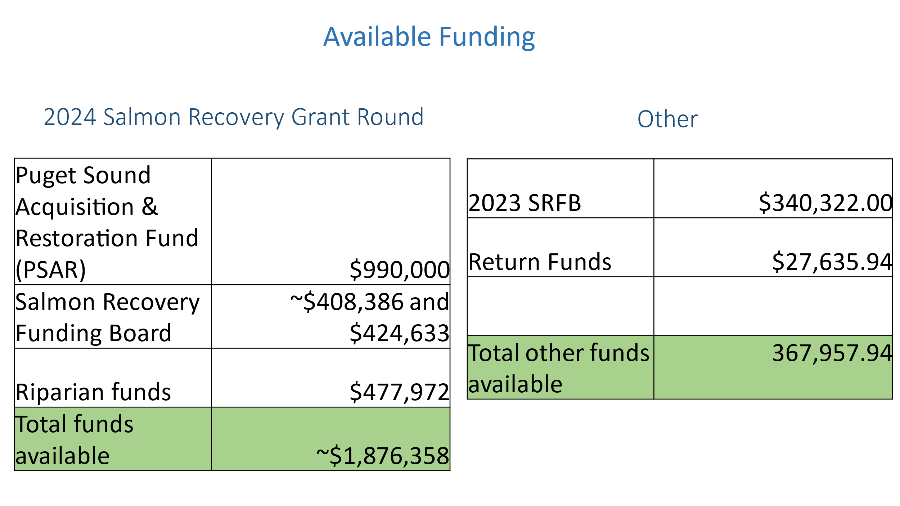

**WSPER Lead Entity 2024 Salmon Habitat Project Grant Round Schedule**

|  |  |
| --- | --- |
| **Date** | **Description** |
| October 3 | Call for projects, scoring criteria, & Letter of Intent are distributed |
| November 28 | Discuss projects, letter of intent, call for projects as needed |
| January 3 | Letter of intent due |
| January 9 | Sponsors present their projects and get feedback |
| Feb 21 | Preliminary project applications due in PRISM (do not hit submit) |
| Jan 30 – Early March | Application technical review period |
| March 12 & 13 | Site visit w/SRFB review panel |
| March 28 | SRFB Review Panel comment form released identifying projects as “Clear,” “Conditioned,” “Needs More Information,” or “Project of Concern.” Monitoring Panel will provide comments for monitoring projects. |
| April 8 | 1-hr call w/SRFB Panel for project sponsors to discuss “Need More Information,” “Project of Concern,” or “Conditioned” projects |
| April 17 | Sponsors submit final responses to Review Panel comments |
| May 7 | TAG submits scores to WSPER Coordinator for processing |
| May 14 | TAG meeting: discuss scores and produce ranked list |
| May 28 | WG meeting: TAG chair provides recommendations and requests feedback and approval |
| June 6 | EC meeting: WG chair provides recommendation and requests feedback and approval |
| June 21 | Final applications due in PRISM |
| July 26 | Review Panel comments distribute to sponsors |
| August 12 | Applications with conditioned projects must accept conditions or withdraw project |
| August 13 | Coordinator submits ranked list |
| Sept 24-25 | Salmon Recovery Funding Board awards grants |

|  |  |  |  |  |  |  |  |
| --- | --- | --- | --- | --- | --- | --- | --- |
| Rank | Project Name | Project Phase | Funding Sought | PRISM # | Request | Match | Running Total Request |
| 1 | Dickerson Creek Protection | Acquisition | Riparian+ | [24-1139](https://secure.rco.wa.gov/prism/search/ProjectSnapshot.aspx?ProjectNumber=24-1139) | $ 1,058,300 | $ 1,087,000 | $ 1,058,300 |
| 2 | Finn Creek Estuary Restoration | Restoration/ Construction | PSAR/SRFB | [24-1159](https://secure.rco.wa.gov/prism/search/ProjectSnapshot.aspx?ProjectNumber=24-1159) | $ 250,000 | $ 45,000 | $ 1,308,300 |
| 3 | DeMolay Shoreline Restoration | Restoration/ Construction | PSAR/SRFB | [24-1161](https://secure.rco.wa.gov/prism/search/ProjectSnapshot.aspx?ProjectNumber=24-1161) | $ 162,671 | $ 666,472 | $ 1,470,971 |
| 4 | Dyes Inlet Lagoon Bulkhead Removal | Restoration/ Construction | PSAR/SRFB | [24-1148](https://secure.rco.wa.gov/prism/search/ProjectSnapshot.aspx?ProjectNumber=24-1148) | $ 97,030 | $ 297,570 | $ 1,568,001 |
| 5 | East Kitsap Steelhead Water Type Assessment | Planning/ Assessment | PSAR | [24-1170](https://secure.rco.wa.gov/prism/search/ProjectSnapshot.aspx?ProjectNumber=24-1170) | $ 300,000 | $ 53,000 | $ 1,868,001 |
| 6 | Barnabee Culvert and Armor Removal, Bridge Replacement, Stream Restoration | Restoration/ Construction | 21-23 PSAR return funds (expiring June 30, 2025) and $212,364.06 of 2023 Funds | [24-1167](https://secure.rco.wa.gov/prism/search/ProjectSnapshot.aspx?ProjectNumber=24-1167) | $ 250,000 | $ 170,917 | $ 250,000 |
| 7 | WCC Riparian Project | Stewardship | Partly funded w $127,957.94 of 2023 SRFB funds + balance of 2024 funds | [24-1168](https://secure.rco.wa.gov/prism/search/ProjectSnapshot.aspx?ProjectNumber=24-1168) | $ 127,958 | $ 42,756 | $ 127,958 |
| 8 | Smith Bulkhead Removal upland planting (Battle Point) | Restoration/ Construction | PSAR/SRFB | [24-1149](https://secure.rco.wa.gov/prism/search/ProjectSnapshot.aspx?ProjectNumber=24-1149) | $ 210,439 | $ 55,447 |  |
| 9 | Skunk Bay Armor Removal (2) | Planning/ Design | PSAR/SRFB | [24-1140](https://secure.rco.wa.gov/prism/search/ProjectSnapshot.aspx?ProjectNumber=24-1140) | $ 65,180 | $ 34,267 |  |
| 10 | Springbrook Culvert Complex at High School Road | Planning/ Design | PSAR/SRFB | [24-1147](https://secure.rco.wa.gov/prism/search/ProjectSnapshot.aspx?ProjectNumber=24-1147) | $ 896,856 | $ 233,912 |  |
|  |  |  |  |  | $ 3,418,433.94 | $ 2,686,341 | $ 2,245,959 |

**2024 Salmon Habitat List - WSPER TAG Recommended Ranking**