Additional Project Information 2024 WSPER Proposed Salmon Habitat Projects

Project Name | Sponsor | Project Phase | Funding Sought | PRISM Number/Link | Request | Match | Notes
WRIA 15 Fish Passage Inventory 2024 | South Puget Sound Salmon Enhancement Group (SPSSEG) | Planning/Assessment | PSAR/SRFB | 24-1145 | $106,000.00 | $19,000.00 | Requested letter of support from the region.
East Kitsap Steelhead Water Type Assessment | Wild Fish Conservancy | Planning/Assessment | Riparian | 24-1170 | $300,000.00 | $53,000.00 | Applying for Riparian option; requested letter of support from the region.
Dickerson Creek Protection | Great Peninsula Conservancy | Acquisition | Riparian+ | 24-1139 | $1,058,300.00 | $1,087,000.00 | Applying for Riparian option; need to add to the 4-Year Workplan
Dyes Inlet Lagoon Bulkhead Removal | Kitsap County | Restoration/Construction | PSAR/SRFB | 24-1148 | $127,530.00 | $297,570.00 | Applied for ESRP as match
Smith Bulkhead Removal upland planting (Battle Point) | Mid Sound Fisheries Enhancement Group | Restoration/Construction | PSAR/SRFB | 24-1149 | $204,500.00 | $147,000.00
Springbrook Culvert Complex at High School Road | City of Bainbridge Island | Planning/Design | PSAR/SRFB | 24-1147 | $1,325,000.00 | $233,912.00
Finn Creek Estuary Restoration | Wild Fish Conservancy | Restoration/Construction | PSAR/SRFB | 24-1159 | $250,000.00 | $45,000.00
Skunk Bay Armor Removal (2) | Mid Sound Fisheries Enhancement Group | Planning/Design | PSAR/SRFB | 24-1140 | $56,000.00 | $35,000.00
Kitsap Creek at Northlake Way | City of Bremerton | Restoration/Construction | PSAR Large Cap | 24-1143 | $1,251,158.00 | $187,674.00
North Creek Culvert Replacement at Harborview Dr | City of Gig Harbor | Restoration/Construction | PSAR Large Cap | 24-1141 | $7,480,000.00 | $ $1,320,000.00
DeMolay Shoreline Restoration | Pierce Conservation District | Restoration/Construction | PSAR/SRFB | 24-1161 | $162,671.00 | $508,721.00 | Using ESRP as match
Schoolhouse Creek at Tidewater | Pierce County | Restoration/Construction | PSAR Large Cap | 24-1199 | $3,315,000.00 | $585,000.00
Barnabee Culvert and Armor Removal, Bridge Replacement, Stream Restoration | Bainbridge Island Land Trust | Restoration/Construction | Riparian | 24-1167 | $200,000.00 | $175,109.00 | Applying for Riparian option, cleared in 2022
WCC Riparian Project | Kitsap Conservation District | Stewardship | Riparian | 24-1168 | $242,000.00 | $42,756.00 | Cleared in 2022, some worksites have changed
 |  |  |  |  | Request  $4,032,001.00  Large Cap Request  $12,046,158.00 | Match  $2,644,068.00  Large Cap Match  $2,092,674.00

Additional Project Information WSPER Proposed Salmon Habitat Projects
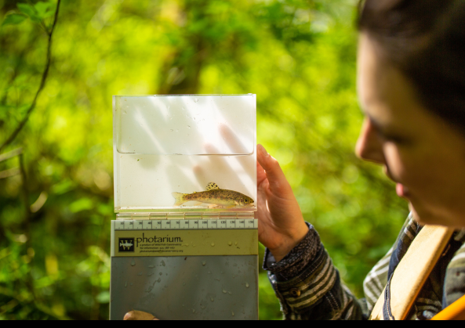  East Kitsap Steelhead Water Type Assessment  Sponsor: Wild Fish Conservancy  Funding Source: Riparian  East Kitsap Steelhead Water Type PRISM Project  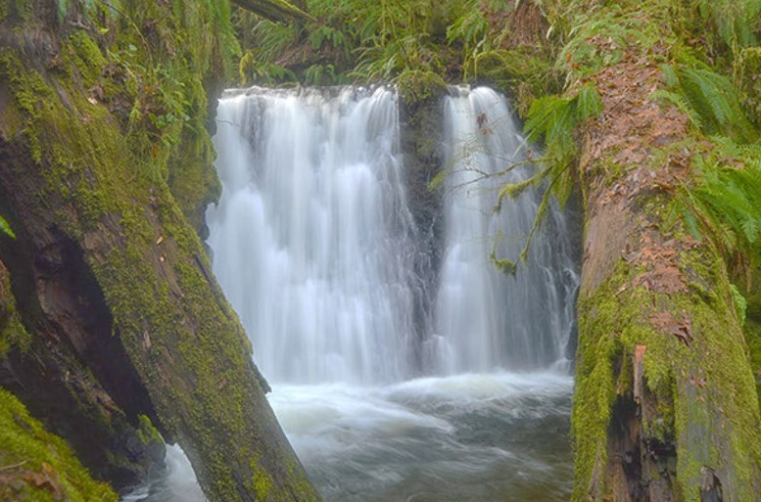  Dickerson Creek Protection (Ueland Tree Farm easement 162 acres)  Sponsor: Great Peninsula Conservancy  Funding Source: Riparian+  Dickerson Creek Protection PRISM Project  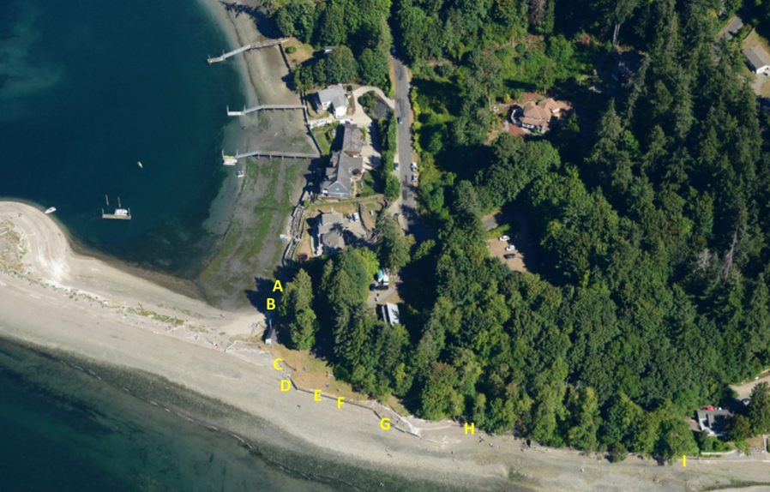  DeMolay Shoreline Restoration  Sponsor: Pierce Conservation District  Funding Source: PSAR/SRFB  DeMolay Shoreline Restoration PRISM Project  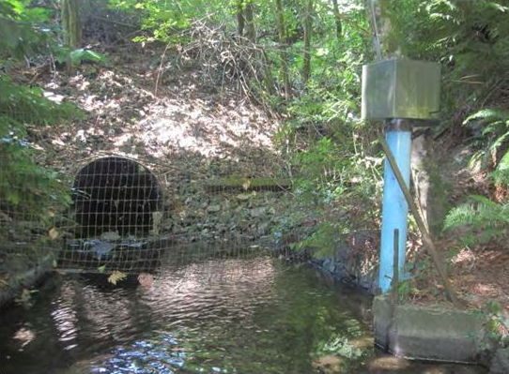  Kitsap Creek at Northlake Way  Sponsor: City of Bremerton  Funding Source: PSAR Large Cap  Kitsap Creek at Northlake Way PRISM Project  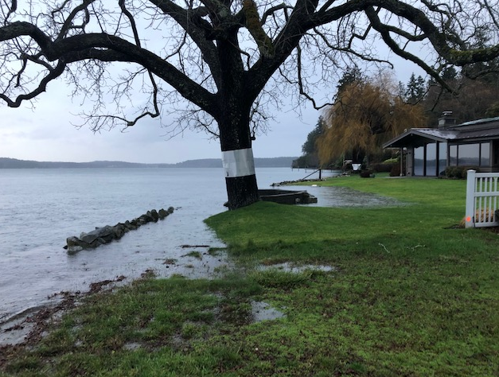  Smith Bulkhead Removal upland planting (Battle Point)  Sponsor: Mid Sound Fisheries Enhancement Group  Funding Source: PSAR/SRFB  Smtih Bulkhead Removal PRISM Project  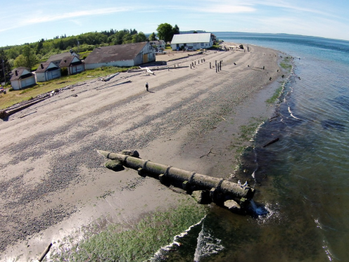  Finn Creek Estuary Restoration  Sponsor: Wild Fish Conservancy  Funding Source: PSAR/ SRFB  Finn Creek Estuary Restoration PRISM Project  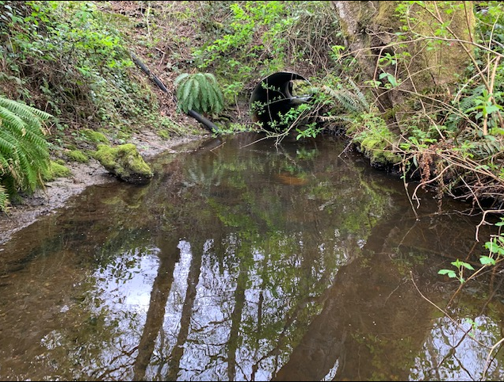  Barnabee Culvert and Armor Removal, Bridge Replacement, Stream Restoration  Sponsor: Bainbridge Island Land Trust  Status: Previously Cleared/Legislative Alternate  Funding Source: Riparian  Barnabee PRISM Project | 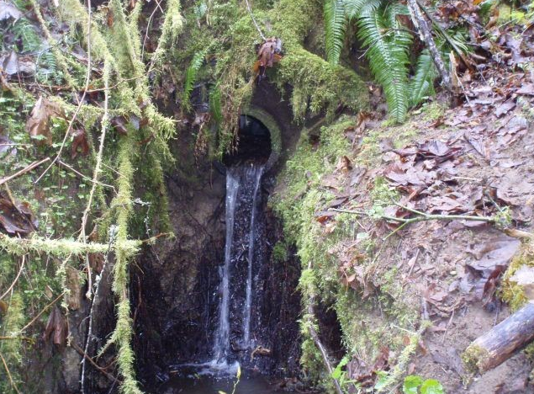  WRIA 15 Fish Passage Inventory 2024  Sponsor: South Puget Sound Salmon Enhancement Group  Funding Source: PSAR/SRFB  WRIA 15 Fish Passage PRISM Project  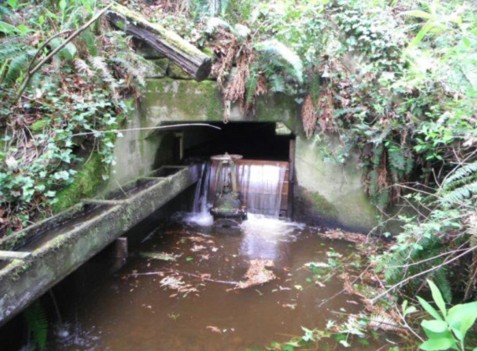  North Creek Culvert Replacement  Sponsor: City of Gig Harbor  Funding Source: PSAR Large Cap  North Creek Culvert Replacement PRISM Project  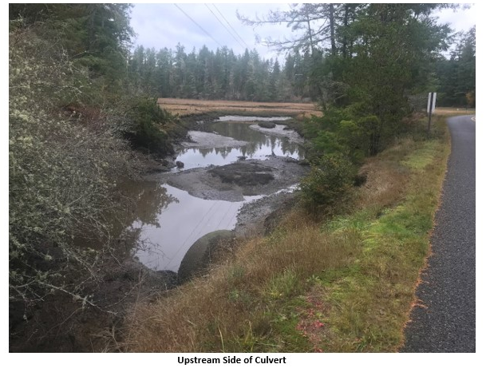  Schoolhouse Creek at Tidewater  Sponsor: Pierce County  Funding Source: PSAR Large Cap  Schoolhouse Creek at Tidewater PRISM Project  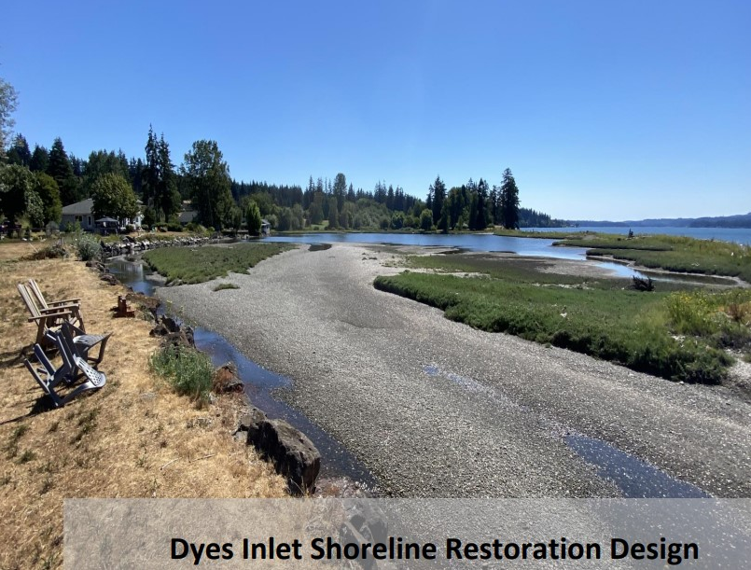  Dyes Inlet Lagoon Bulkhead Removal  Sponsor: Kitsap County  Funding Source: PSAR/SRFB  Dyes Inlet Lagoon Bulkhead Removal PRISM Project  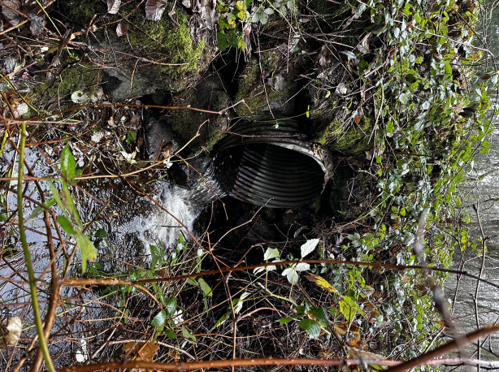  Springbrook Culvert Complex at High School Road  Sponsor: City of Bainbridge Island  Funding Source: PSAR/SRFB  Springbrook PRISM Project  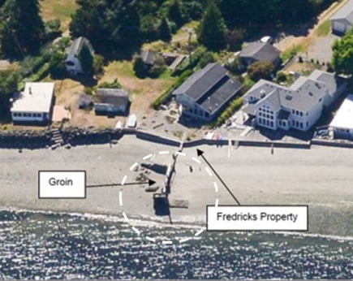  Skunk Bay Armor Removal  Sponsor: Mid Sound Fisheries Enhancement Group  Funding Source: PSAR/SRFB  Skunk Bay Armor Removal PRISM Project  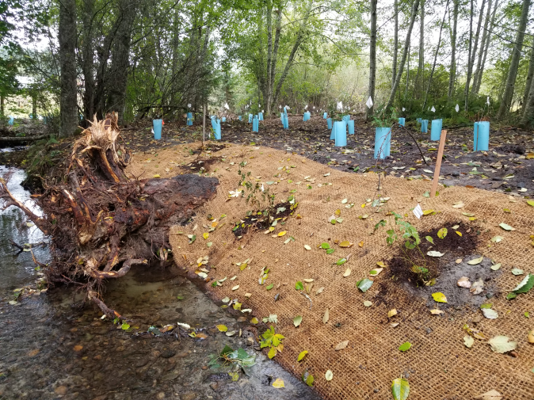  WCC Riparian Project  Sponsor: Kitsap Conservation District  Status: Previously Cleared/Legislative Alternate  Funding Source: Riparian  WCC Riparian PRISM Project

Photos were obtained from project applications or were photographed by WSPER staff. See project applications for existing source citations.

