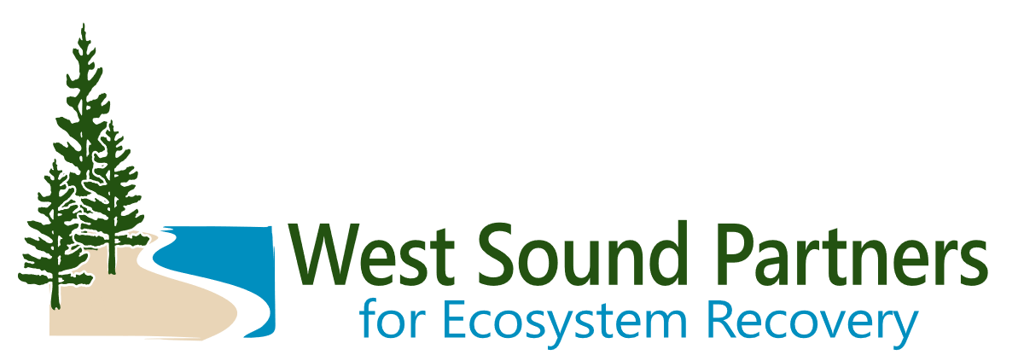

February 7, 2024

Renee Johnson

West Sound Partners for Ecosystem Recovery Coordinator

Kitsap County Department of Community Development

619 Division Street, MS-35

Port Orchard, WA 98366

**Subject: Letter of Support for Pierce Conservation District’s Filucy Bay Armor Removal and Shoreline Restoration Project**

The West Sound Partners for Ecosystem Recovery (WSPER)—a Lead Entity for salmon recovery and a Local Integrating Organization for ecosystem recovery made up of technical experts, practitioners, and citizens of the cities, counties, and tribes in eastern Water Resource Inventory Area 15—express support for Pierce Conservation District’s Filucy Bay Armor Removal and Shoreline Restoration Project.

This armor removal project would remove 100 linear feet of creosote-treated wood armor and concrete armor from the nearshore and reestablish riparian vegetation to support natural coastal processes and benefit nearshore habitat used by juvenile Chinook, other ESA-listed salmonids, and two species of forage fish spawn in the drift cell (an essential prey item for juvenile Chinook).

Our partners constantly work to identify and prioritize projects and find funding to recover ecosystems and salmon populations in West Puget Sound. We have identified the construction phase as a priority action in our 2016 Ecosystem Recovery Plan.

The West Sound Partners for Ecosystem Recovery support this application. Shoreline restoration is a high priority for salmon and ecosystem recovery in our region, and we look forward to seeing the project move forward.

Sincerely,

Renee Johnson| WSPER Coordinator

Kitsap County Department of Community Development

Port Orchard, WA 98366