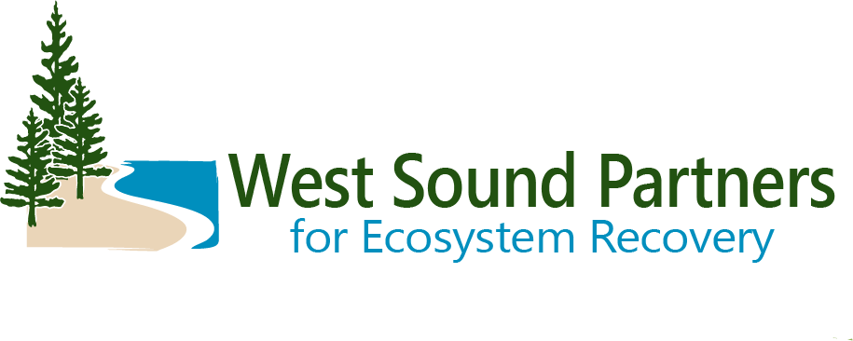
Technical Advisory Group
DRAFT Meeting Summary
September 19, 2023 | 9:30 a.m. – 11:00 a.m.
Virtual Zoom Meeting

Meeting Objectives: for the Technical Advisory Group to:
- Discuss salmon recovery priorities
- Discuss standing and emerging topics

Decisions by TAG
Approved consent agenda and meeting summary
Approved annual workplan

Action Items Status
Renee to follow up with poll via email regarding 2024 meeting dates/times.  Renee will send poll on whether members prefer voting to be anonymous or disclosed.  Renee to send out call for projects September 30.  Brittany to check on the Blackjack watershed protection and restoration plan.  Brittany to clean up 4 Year Workplan spreadsheet with changes and send to the group.  Brittany to send out Salmon Recovery Council update. | Complete  Complete  Complete  Complete  Complete  Complete

Welcome, Introductions, and Business items:
Erik Steffens, TAG Co-Chair, opened the meeting and invited introductions and brief updates from each member.
Brittany: Thank you to BILT for hosting beaver workshop.
Steve Todd: Tribe gathering pre-restoration data at Rose Point.
Mary Krauszer: Shore Friendly S Sound heading into 23-25 biennium funding and Shore Friendly overall was awarded HSIL money for outreach. DeMolay project- finished preliminary design and headed toward construction funding in 2024. Henderson Bay armor removal project- awarded ECY funding and other funding to hopefully go to construction next year.
Kay Caromile: ESRP starting grant rounds soon, finalizing schedule. Small grants may begin in November. Trying to fit all 4 grant programs into a 5 month period. Schedule should be announced later this month. Bridget Kaminski will be taking over as RCO grant manager for West Sound LE. Kay will still be covering ESRP and keeping a couple projects that are finishing up.
Marty Ereth: Purdy at 160th fish passage- construction likely next year. 2 projects on 144th (Tacoma power lines)- 30% design using consultants.
Tracy Banaszynski: Bridge replacement in progress at Rose Point and going well.
Bridget Kaminski: Taking over West Sound LE as RCO grant manager.
Jamie Glasgow: Finn Creek- coordinating with consultant and County; survey data just came in. Also working with BILT on headwaters of Springbrook Creek. Culvert has been removed and banks are being stabilized.
Christina Kereki: SF Kitsap will continue being part of the ESRP program through at least 2025. Project in Dyes Inlet is expanding to incorporate 2 more parcels. PSRF is working on an Olympia Oyster project in that lagoon this fall.
Christian Berg: received federal DOT project for Springbrook project under Fletcher Bay Drive Considering also applying for NOAA fish passage barrier removal grant.
Zack: Moving forward soon with Ruby Creek project on Sidney Rd- opens up access to work by GPC and KCD. Johnson Creek estuary project at Port Orchard Blvd and SR 166 is in design by WSDOT. Zack transitioning to City of Bremerton on Thursday.
Business items:
Erik opened the floor for public comment before decisions are made. No members of the public present.
Decision: There was a motion to approve the consent agenda with edits to the agenda. Motion (Steve), second (Mary). Unanimously approved. (Edits: meetings will be the third Thursday of the month, not the second. Add SRC update from Brittany.)

Discussion topic: 2024 meeting schedule. No decision today.

Action item: Renee to follow up with poll via email.

Salmon Recovery Priorities
Renee shared the annual workplan, which includes the grant round process, updating and tracking projects in the Salmon Recovery Portal, outreach, implementing EK Steelhead Recovery Plan, updating salmon strategy, and to update and refine 4 Year Workplan).
Decisions: There was a motion to approve workplan. Motion (Mary), second (David). Unanimously approved.
Brittany provided summary of 4 Year Workplan update (see follow up summary).
Action item: Brittany to clean up spreadsheet with only changes and send that out to the group.
Action item: Brittany to check on the Blackjack watershed protection and restoration plan.
Renee provided an update on RCO’s Riparian Policy for distributing ($23.87M) in riparian funds.

2023-2024 Grant Round Competition:
Summary from Renee on Riparian funding: At last week’s Salmon Recovery Funding Board, Nick Norton presented four options to the board. One was a new idea where there would be no statewide competition; all the funds would be distributed to the Regions based on the statewide allocation formula. Option 4: Fund each LE at base of at least $300k. The preliminary number for E Kitsap is $477,972 for eligible riparian projects. This money can be used to fund projects on the 2023 list or the 2024 list and may allow for some carryover if needed. This is something we should discuss again in November as the policy for distributing these funds is finalized.
- Restrictions: limit of 10% of whole region’s funding for Puget Sound can be spent on assessments.
- Types: acquisition, riparian planting, invasive species removal, stewardship, assessment/inventory, instream & floodplain habitat restoration.
The regular grant round is ~$266,000 in SRFB funds anticipated/available September 2024 and ~$990,000 in PSAR funds is anticipated/available in July 2025.
Renee asked when the TAG wants the call for projects to be released. (Generally, Nov/December but could be earlier). Since earlier was desired, the call for projects will go out September 30.
Action Item: Renee to send out call for projects September 30.
Renee proposed simplifying the letter of intent process by using Salmon Recovery Portal to track projects. Most projects are already in SRP because they are on our 4-year Workplan and Planned Project Forecast List. Renee offered to work with sponsors to update planned projects in SRP instead of requiring a separate letter of intent.
Renee asked if the TAG wanted to change scoring criteria for the 2024 grant round. No changes were recommended.
Because of prior requests to share all raw scores with the group, Renee suggested polling the group regarding anonymity of scoring.
Action item: Renee will send poll on whether members prefer voting to be anonymous or disclosed.
Jan 9 due date for Letters of Intent sounds good.
Group leaned toward mid-March for site visits.
Future discussion is still needed on how many TAG members from each organization should vote.
Standing and Emerging Topics
Letters of support (requested or needed):
Sarah Wilson is requesting two letters on behalf of the City of Bremerton, one for Parish Creek in Gorst and one for Northlake Way. The City of Bremerton is applying for NOAA grant with $11,658,497 requested for Northlake Way design, construction, and acquisition. 1 Acquisition needed. Funds are being sought for a Parrish Creek design and bid package.
Salmon Recovery Council Update – due to limited time, Brittany will provide a written SRC update.
Action item: Brittany to send out Salmon Recovery Council update.
Salmon Recovery Chapter Update (no recent update).
Wrap Up and Next Steps
Erik thanked everyone for participating and closed the meeting.
Meeting adjourned.

Attendees:
Brittany Gordon, Kitsap County / WSPER team
Christian Berg, City of Bainbridge Island
Christina Kereki, Kitsap County Natural Resources Planner
David Tucker, Kitsap County Public Works
Erik Steffens, Great Peninsula Conservancy
Jamie Glasgow, Wild Fish Conservancy
Kay Caromile, RCO
Marty Ereth, Pierce County
Mary Krauszer, Pierce Conservation District
Renee Johnson, Kitsap County / WSPER Coordinator
Sarah Wilson, City of Bremerton
Steve Todd, Suquamish Tribe/ Co-Chair
Tracy Banaszynski, Mid-Sound FEG

