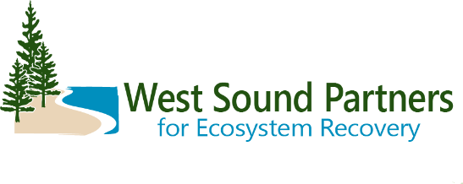

WSPER Lead Entity 2024 Salmon Habitat Project Grant Round Schedule
Phase | Date | Description
Planning | October 3 | Call for projects
 | November 21 | Discuss projects, letter of intent, call for projects as needed
 | January 3 | Letter of intent due
 | January 9 | Sponsors present their projects and get feedback
 | January 30 | Preliminary project applications due in PRISM (do not hit submit)
 | Jan 30 – Feb 19 | Application technical review period
 | Feb 20 TBD | Site visit w/SRFB review panel; First choice: Mar 12 & 13; Second choice: Mar 5 & 6; Third choice: Feb 20 & 21
 | March 28 | SRFB Review Panel comment form released identifying projects as “Clear,” “Conditioned,” “Needs More Information,” or “Project of Concern.” Monitoring Panel will provide comments for monitoring projects.
 | April 8 & 9 | 1-hr call w/SRFB Panel for project sponsors to discuss “Need More Information,” “Project of Concern,” or “Conditioned” projects
LE Develops Habitat List | April 17 | Sponsors submit final responses to Review Panel comments
 | May 7 | TAG submits scores to WSPER Coordinator for processing
 | May 14 | TAG meeting: discuss scores and produce ranked list
 | May 28 | WG meeting: TAG chair provides recommendations and requests feedback and approval
 | June TBD | EC meeting: WG chair provides recommendation and requests feedback and approval
 | June 21 | Final applications due in PRISM
Funding Decision | July 26 | Review Panel comments distribute to sponsors
 | August 12 | Applications with conditioned projects must accept conditions or withdraw project
 | August 13 | Coordinator submits ranked list
 | Sept 24-25 | Salmon Recovery Funding Board awards grants

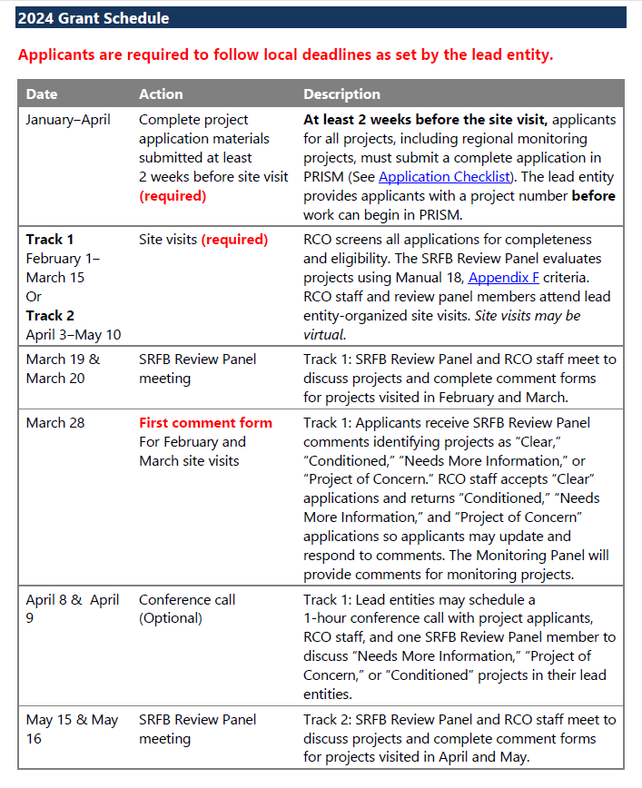
RCO schedule
