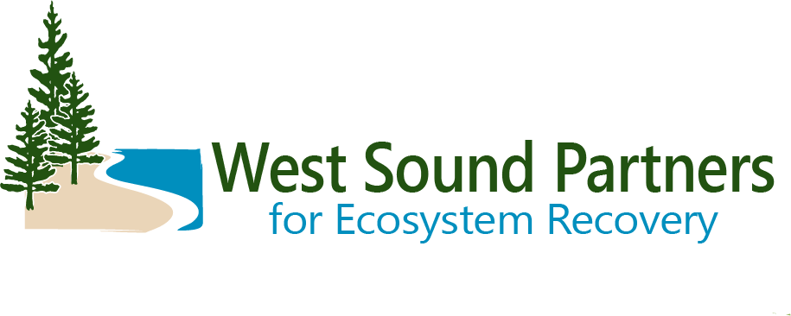
Working Group Group
DRAFT Meeting Summary
October 10, 2023 | 9:30 a.m. – 12:00 p.m. and 12:00 -1:30 p.m.
Hybrid Meeting with in-person Field Trip

Location: Port Blakely Meeting Room
Kitsap County Admin Building
619 Division Street, Port Orchard, WA 98366

Meeting Objectives: for the Working Group to:
- Discuss LE and LIO business
- Hear Guest presentations & updates
- Attend a stormwater field trip
Decisions by WG
Decision: approved October agenda and June meeting summary.
Decision: Motion to approve the annual workplan with the condition that Task 5 will be addressed further.

Action Items

Welcome and Announcements
Zack Holt, WG Co-Chair, welcomed the group, invited introductions, reviewed agenda and meeting purpose, and gave opportunity for public comment.
Introductions/Roundtable:
Renee Johnson- Kitsap County DCD will have table at Salmon Tours.
Christian Berg- salmon monitoring program got transferred to City of Bainbridge.
Marty Ereth- Minter, Purdy, Little Minter projects, 160th project going to construction next year.
Steve Todd- tribal biologists re-starting forage fish spawning surveys focused on fall/winter months .
Christina Kereki- welcoming Amy Smalley to our PEP and Shore Friendly team.
Amy Smalley- Kitsap Salmon Tours November 4th.
Anna McClelland- WSU is the interim Water Stewardship Coordinator
Jim Aho- looking to procure 10 properties for wildlife corridor between Illahee Preserve and Illahee state park. Also trying to purchase 30 acres with a dam on it in Illahee watershed, which needs a spillway per Ecology.
Rebecca Brown- HSIL liaison. HSIL will be publishing habitat investment priorities on Thursday.
Tracy Banaszynski- had final bridge inspection at Rose Point yesterday. Rest of the project will be done next summer.
Sean Goldsmith- working on a culvert prioritization list.
Dustin Haydock- just finished public comment period of WMP prospectus. There were 30 comments submitted, generally supportive. Working on responding to comments in October/November. Also trying to establish a wholesale native plant nursery in Kitsap County- geared toward restoration.
Barbara Ann- water quality report for Key Peninsula: trying to make WQ data accessible to public. State of the Watershed forum is on Oct 25.
Brenda- Wetland wonders workshop at Islandwood was a success, focused on working with beavers. Springbrook Creek fish barrier removal is complete.
Elizabeth Eareckson- Kitsap CD. Completed fish barrier removal project this summer on Little Anderson Creek and getting under contract for 2 next summer.
Action: approved October agenda and June meeting summary. Approved unanimously. Moved (Steve), second (Christian). No abstentions.
Opportunity for public comment: No public comments were presented.

The group discussed meeting dates for 2024. Renee explained that in her poll to the TAG, feedback was that people want to meet more frequently for shorter periods. Members do not want to meet in person too frequently due to travel time- hybrid options work well for many.

Renee went through the annual workplan for the LIO.
Action: Motion to approve the annual workplan with the condition that Task 5 will be addressed further: Steve. Second: Christina/Barbara. No dissentions, approved unanimously.
Renee gave update on mobile marine pump-out pilot.

6 WSPER members attended Government to Government training and said it was very valuable- we are looking for more opportunities in the future.
Renee gave an update on the ERP Update.

Guest Speakers- WSDOT Olympic Region: Kaitlin Fauver/ Damon Romero- WSDOT Olympic Region Fish Passage Predesign
Progressive Design Build contract for Kitsap bundle was awarded to Hewitt. Kaitlin Fauver and Damon Romero shared the WSDOT GIS map showing barrier replacements and design year. Another project WSPER may want to be engaged in is the Gorst Corridor Study- not under contract yet but coming down the line. WSDOT fish passage webmap pulls from the WDFW webmap just to display the WSDOT owned crossings, but the WSDOT data is updated weekly. Some of the “corrected barrier” data points on the WSDOT/WDFW map are outdated (old data set- some are fishways, etc). WSDOT also has a monitoring program to assess success of barrier replacements.

Guest Speaker- Rebecca Brown, Habitat SIL
Sound Choices Checklist Update: Rebecca Brown (DNR/HSIL) presented on the Sound Choices Checklist. Encourages local jurisdictions to align comp plans with Action Agenda and Implementation Strategies. Help jurisdictions understand how their decisions and policies are advancing Puget Sound Recovery. Provide the Puget Sound recovery community with a resource to use when engaging in local Comprehensive Plan updates. Kitsap County did preliminary review of the checklist and provided feedback (among other counties- Island and Skagit). Commerce is creating new salmon recovery grants.

Guest Speakers: Dustin Bilhimer, Emily McCartan- Ecology SSIL; Audrey Coyne- DOH Shellfish SIL
SSIL- upcoming investment priorities.
*Current SSIL funding opportunity open. Support management of small OSS and Large OSS and septage disposal needs to reduce fecal pollution impacts on shellfish growing areas.
RFP Announcements: https://pugetsoundestuary.wa.gov/stormwater-sil-rfp/
Stormwater and Land Use Workshop Participants: https://pspwa.box.com/s/bozkrndptiuksq1vsi0zetpm2r115nb2

Guest Speaker: Jenn Grimm (PSP)
PSP Strategic Funding Team update- Jenn Grimm (PSP) gave an update on the strategic funding team. Question- how many projects can your team work on at once? Response- will depend on skillset of the team.

Wrap Up and Next Steps
Zack Holt thanked everyone for participating and closed the meeting.
The meeting adjourned.

Attendees:

Amy Smalley, WSU Extension
Anna McClelland- WSU Extension
Barbara Ann Smolko- Pierce County
Brenda Padgham, Bainbridge Island Land Trust
Brittany Gordon, Kitsap County
Christian Berg, City of Bainbridge Islsand
Christina Kereki, Kitsap County Natural Resources Planner
Dustin Haydock, Waterman Mitigation Partners
Elizabeth E, Kitsap Conservation District
Jim Aho, Illahee Community
Marty Ereth, Pierce County
Rebecca Brown, DNR, HSIL
Renee Johnson, Kitsap County / WSPER Coordinator
Sarah Wilson, City of Bremerton
Sean Goldsmith- Pierce County
Steve Todd, Suquamish Tribe
Tracy Banaszynski, Mid-Sound FEG
Zack Holt, City of Bremerton

Guest Attendees:
Kaitlin Fauver, WSDOT Olympic Region
Damon Romero, WSDOT Olympic Region
Dustin Bilhimer, Ecology SSIL
Emily McCartan- Ecology SSIL
Audrey Coyne- DOH Shellfish SSIL
Jenn Grimm- PSP, Strategic Funding Team

