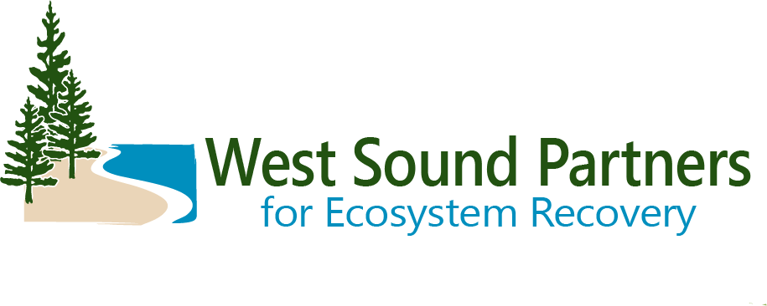
Technical Advisory Group
DRAFT Meeting Summary
July 18, 2023 | 9:30 a.m. – 11:00 a.m.
Virtual Zoom Meeting

Meeting Objectives: for the Technical Advisory Group to:
- Discuss salmon recovery priorities
- Discuss standing and emerging topics

Decisions by TAG
Approved consent agenda
Action Items
4 Year Workplan- project sponsors to send project updates and new projects to Brittany by July 28.
Brittany Gordon to send out follow up to PSAR RFP discussion requesting needed information before the September TAG meeting.
At the September TAG meeting, Brittany will request a formal recommendation on how WSPER should vote on the 25-27 PSAR Large Cap RFP at the September SRC meeting.
Brittany to recruit ad-hoc subcommittee to discuss PSAR large cap RFP.
Renee to send draft outline of Salmon Recovery Plan (Shared Strategy Chapter) update
Christian Berg to send information on Springbrook Creek scope change and cost increase

Welcome and Announcements
Steve Todd, TAG Co-Chair, opened the meeting.
Opportunity for public comment (none received).
Brief Updates from Members:
Steve Todd, Suquamish Tribe, upcoming estuary restoration effectiveness monitoring project at Rose Point and potentially Point No Point. Ideally looking at Before and After Changes and conditions.
Carin Anderson, Kitsap Conservation District, moving forward with 3 FFFPP fish passage projects on Ruby Creek. KCD has been doing inventories on Burley and Grovers Creeks as well.
Tracy Banaczynski, Mid-Sound, Rose Point project moving forward this summer.
Lisa Reynolds, Mid-Sound project manager, critical landowner meetings are coming up at Point No Point.
Mary Krauszer, Shoreline program manager Pierce CD, funding from ECY oil spill grant and NEP grant to support Henderson Bay armor removal project. Pierce CD has also been invited to submit final application for Coastal Watersheds Grant for that project.
Christina Kereki, Kitsap Co, Shore Friendly, bulkhead removal project in Dyes Inlet is moving along.
Brenda Padgham, BILT, Springbrook Creek project moving along. Beaver workshop coming up Sept 17.
Christian Berg, City of Bainbridge Island, Springbrook and Cooper culvert projects moving forward.
Brittany Gordon, Kitsap County/ WSPER team, Kitsap Natural Resource Asset Management Program is moving along toward developing desired levels of service.
Scott Steltzner, Squaxin Tribe, Tribe recently met with Navy. Navy has a plan to replace all their fish culverts in Squaxin U & A.
Sarah Wilson, Bremerton stormwater, SMAP accepted by ECY. Stormwater treatment vault designs are at 30% design, including a large vault that discharges to Kitsap Lake.
Marty Ereth, Pierce County, 30% design on 2 fish passage projects on Tacoma power lines at 144th St. Permitting progress on 160th (2024 construction likely). 94th street culvert design starting.
Motion to approve consent agenda (Marty). Second (Mary). Approved. All in favor. No abstentions. None opposed.
Salmon Recovery Priorities
2023 recommended list approved by WG and EC, to be uploaded into PRISM by August 4.
4-Year Workplan Update
Brittany has sent emails to sponsors identifying projects potentially needing an update. Thank you to those who have already responded. If you have new projects to submit, send Brittany a project name, brief description, and sponsor. These are for projects that might reasonably be expected to apply to the grant round for funding in the next 4 years. Due to Brittany by July 28.
Steve asked about vetting projects on the 4 year workplan (especially new projects). Some come from watershed plan work, so there is some vetting there. Most vetting occurs at the ranking stage. If WSPER team sees any projects proposed that are surprising, we will bring them to the attention of the TAG.
Salmon Recovery Chapter Update
WSPER staff have been in coordination with PSP and their consultant ESA, who was hired to help some watersheds update their salmon recovery chapters. We have a preferred timeline of January – December 2024 and would prefer to use ESA to write the update. We have a draft outline but this is very flexible depending on what the subcommittee wants to see in the update. Tom Ostrom may be available to help on contract as well. We will be recruiting a subcommittee soon- please let us know if you are interested.

Salmon Recovery Council advisory vote for PSAR Large Cap (see memo)
PSP is working on the 25-27 PSAR Large Cap RFP. Current options are to retain the 23-25 PSAR Large Cap RFP (preferred option by PSP), revert back to the 21-23 RFP, or draft a new RFP. Major difference is 23-25 RFP includes extra points for projects that benefit salmon stocks that are 1) closest to recovery, 2) acutely limiting harvest, and 3) closest to extinction.
WSPER members discussed these options. WSPER has received PSAR large cap funding 3 times and may have upcoming projects such as Point No Point that are regionally significant and expensive that may qualify. Steve asked if steelhead were considered for prioritization and Brittany received an answer from PSP that steelhead were not considered. The extra points would make it much more difficult for WSPER to compete for large cap funding. There was much discussion on whether this is the best thing for salmon recovery. There was discussion about trying to increase support from sportfishing community for salmon recovery.
There was some support expressed for a hybrid RFP option that gives extra points for stocks closest to extinction but not for stocks closest to delisting or acutely limiting harvest.
Next meeting of SRC is July 27 9 AM-3:30 PM (available streaming on TVW https://www.tvw.org/watch/?clientID=9375922947&eventID=2023071018 ). SRC will be taking an “advisory vote” to inform the Leadership Council. Another “advisory vote” will occur in September, and Leadership Council will make a decision in November.
Recommendation to Brittany (SRC rep) at July meeting: Brittany will tell the SRC that we are open to a hybrid RFP but support would depend on the details in that RFP. Also we want to know if/how steelhead were considered for prioritizing watersheds.
Standing and Emerging Topics
Christian informed the group that there will be information forthcoming on a scope change to the Springbrook Creek fish passage project. Christian will be sending out materials and requesting a vote to approve a scope change and cost increase for the project (before the next meeting).
Kay Caromile is transitioning to the Klickitat lead entity. She will still be covering ESRP. Transition period- Bridget will likely be covering W Sound first but will take a few months.
Wrap Up and Next Steps
Steve thanked everyone for participating and closed the meeting. Meeting adjourned.
Attendees:
Brenda Padgham, Bainbridge Island Land Trust
Brittany Gordon, Kitsap County / WSPER team
Carin Anderson, Kitsap Conservation District
Christian Berg, City of Bainbridge Island
Christina Kereki, Kitsap County Natural Resources Planner
Kay Caromile, RCO
Lisa Reynolds- Mid-Sound FEG
Marty Ereth- Pierce County
Mary Krauszer, Pierce Conservation District
Renee Johnson, Kitsap County / WSPER Coordinator
Sarah Wilson, City of Bremerton
Scott Steltzner, Squaxin Island Tribe
Steve Todd, Suquamish Tribe/ Co-Chair
Tracy Banaszynski- Mid-Sound FEG

