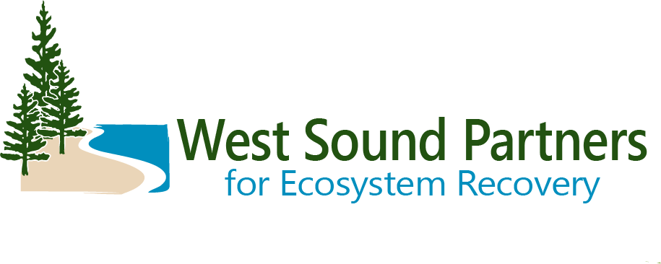
Executive Committee Web Meeting
November 5, 2020 | 1:00 - 2:30 PM
Meeting Summary DRAFT v. 11/18/20

Executive Committee Members in Attendance
Barbara Ann Smolko, Pierce County, Alternate
Charlotte Garrido, Kitsap County, Commissioner
Greg Wheeler, City of Bremerton, Mayor
Jeni Woock, City of Gig Harbor, Councilmember
Kol Medina, City of Bainbridge Island, Councilmember
Leonard Forsman, Suquamish Tribe, Chairman
Mark Dorsey, City of Port Orchard, Public Works Director

Executive Committee Members Not in Attendance
Becky Erickson, City of Poulsbo, Mayor
Jeromy Sullivan, Port Gamble S’Klallam Tribe, Chairman

Welcome and Introduction
Chairman Leonard Forsman, Executive Committee Chair opened the meeting and reviewed the agenda and meeting purpose: Review work completed in 2020 and establish a workplan for 2021 by discussing topics of interests, accepting Operating Guidelines, and providing input on how to strengthen engagement with elected officials and decision makers around local ecosystem recovery priorities and needs.
The Executive Committee established a quorum.

Executive Committee Meeting Summary
After review by the Committee, Councilmember Woock, Gig Harbor, made a motion, seconded by Councilmember Medina, Bainbridge Island, to accept the June 5 meeting summary as final.
Decision: The Executive Committee unanimously passed a motion to accept the draft June 5 WSPER Executive Committee meeting summary as final.

2020 Work Completed
Kirvie Mesebeluu-Yobech, WSPER Coordinator provided an overview of the work WSPER completed in 2020, including the following:
- Allocation of $100,000 plus match to the East Kitsap Forage Fish Monitoring Project
- 2020 Salmon Habitat Project List for an estimated $1.25 million in funding
- East Kitsap Steelhead Recovery Plan
- 2021-22 Salmon Recovery Planned Project list submitted to the State to help demonstrate the funding need
- Minter Creek State Route 302 and Chico Creek Golf Course Road culvert replacements

Ecosystem Coordination Board (ECB) Update
Commissioner Garrido, Kitsap County, provided an update on the October 28 ECB meeting, which included:
- A presentation from Ecology on toxins in fish
- A presentation from Northwest Straits Commission on the value of kelp in the ecosystem
- Discussion of Land Use Subcommittee recommendations for improving land use policy in support of ecosystem recovery (The Subcommittee is chaired by Commissioner Garrido and Commissioner Kate Dean of Jefferson County). Recommendations include developing:
  - Tools to communicate ecosystem recovery/land use issues to elected officials and communities
  - Tools to educate and support landowners acting on their own property
  - A landowner payment system to compensate landowners for protecting/maintaining ecosystem services (see Canadian policy models)
  - Local cumulative impact assessments for land use effects

Jurisdiction Updates
- Councilmember Medina will be resigning from the Bainbridge Island City Council. He has accepted a position as Executive Director of Blue Mountain Community Foundation and will be moving to Walla Walla, WA.
- Councilmember Medina highlighted Bainbridge Island is taking steps to remove the privately owned aquaculture net pens south of the Island. The City has proposed aquaculture related amendments to its Shoreline Master Program (SMP), which is under review by Ecology. The City is also coordinating with Wild Fish Conservancy in its effort to purchase the lease for the existing net pens.
- Mayor Wheeler, Bremerton, highlighted culvert replacements at Kitsap Way and Oyster Bay, and recovery work at Kitsap Lake.
- Commissioner Garrido highlighted Kitsap County is working to set up a Shellfish Protection Area. Barbara Ann Smolko, Pierce County, suggested Commissioner Garrido connect with Leslie Benign, Kitsap Health District, about the Shellfish Protection Area.
- Mark Dorsey, Port Orchard, highlighted the City’s update to its SMP which includes sea level rise considerations. Dorsey also highlighted a culvert replacement at Johnson Creek and removal of overwater homes as part of the Bay Street Project.

2021 Elected Official Engagement
Kirvie Mesebeluu-Yobech reviewed a memo asking the Committee how to support engagement with elected officials and decision makers in 2021. WSPER has additional financial support from Puget Sound Partnership to engage decision makers and electeds next year.
- Chairman Forsman indicated the main priority is to find funding for planned recovery projects.
- Barbara Ann Smolko emphasized the importance of communicating multiple benefits of salmon habitat projects, including improved infrastructure/safety, flood risk reductions, and climate resilience.
- Commissioner Garrido emphasized the importance of visual media to communicate recovery work successes to decision makers and communities.
- Mayor Wheeler echoed the importance of visual media to communicate success stories and explained he has been showing the Bremerton City Council videos of fish passage problems and work completed by volunteers.

WSPER Operating Protocols
Kirvie Mesebeluu-Yobech reviewed a memo highlighting the new WSPER Operating Protocols for the combined Lead Entity and Local Integrating Organization (LIO).
Commissioner Garrido made a motion, seconded by Councilmember Wook, to accept the updated Operating Protocols.
Decision: The Executive Committee unanimously passed a motion to accept the WSPER Operating Protocols.

2021 Chair and Vice-Chair
Councilmember Wook made a motion, seconded by Councilmember Medina, to affirm Chairman Forsman and Commissioner Garrido as Executive Committee Chair and Vice-Chair respectively, for 2021.
Decision: The Executive Committee unanimously passed a motion to affirm Chairman Forsman and Commissioner Garrido as Executive Committee Chair and Vice-Chair respectively, for 2021.

Wrap-Up
The Executive Committee indicated support for the WSPER Coordinator’s recommendation to cancel the scheduled December Executive Committee meeting and hold the next meeting in 2021.

Public Comment(s): None

Staff and Other Attendees
- Kathy Peters, Kitsap County
- Kirvie Mesebeluu-Yobech, Kitsap County / WSPER Coordinator
- Rebecca Hollander, Puget Sound Partnership
- Tom Ostrom, Suquamish Tribe
- Thomas Christian, Triangle Associates / WSPER Support

